Practical 9 — Secure User Registration and Password Hashing

Aim
To register users securely against the database with validated input, duplicate handling and one-way password hashing.

Theory
Secure registration never stores reusable passwords. It validates, checks duplicates, hashes with a salted adaptive function, and verifies with a dedicated check that never decrypts.
- Server validation repeats every browser rule so crafted requests cannot bypass checks.
- Duplicate emails get a friendly rejection with no second row written.
- Passwords are processed with a salted adaptive hash and verified with a timing-safe check; plaintext and hashes never appear in logs or error pages.
- All database access uses parameterised queries and all echoed values are escaped.
- A dedicated migration documents the password-column change for this practical.

Procedure
- Extended the registration flow with a database-backed handler of about 11 KB alongside the file handler.
- Added server validation, duplicate lookup, hashing and parameterised insert.
- Added the password migration and kept the design note aligned.
- Inspected handler and migration on disk; live registration was not re-executed here for lack of PHP and MySQL.
- Hash display intentionally omitted from screenshots for security; marked by design. 6.
7.

Screenshots

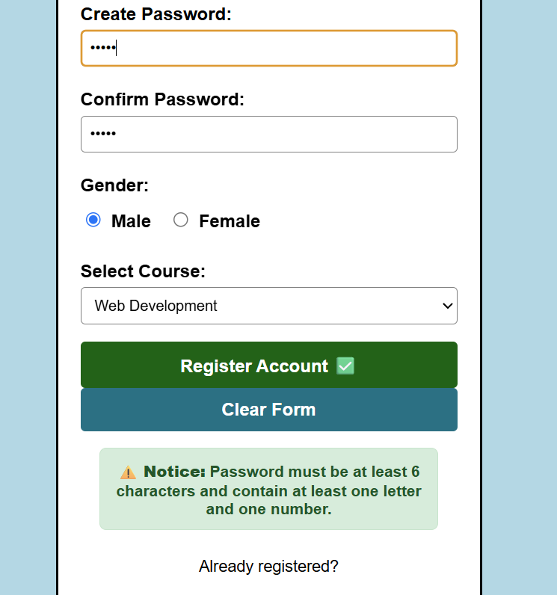

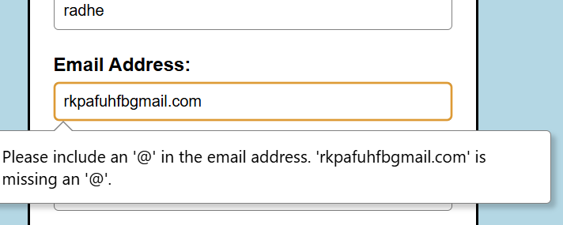

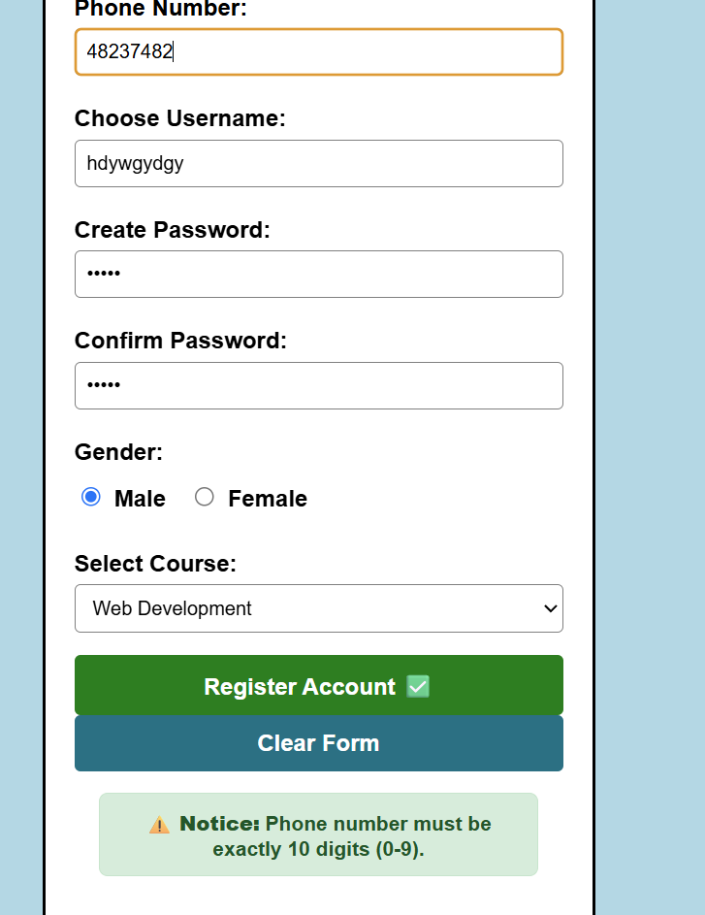
GitHub Repository Link
Practical repository : https://github.com/Rkpatel34/StudentHub/tree/main/studenthub

Conclusion
Practical 9 closed the plaintext era: credentials are validated, deduplicated and stored only as salted hashes.

